[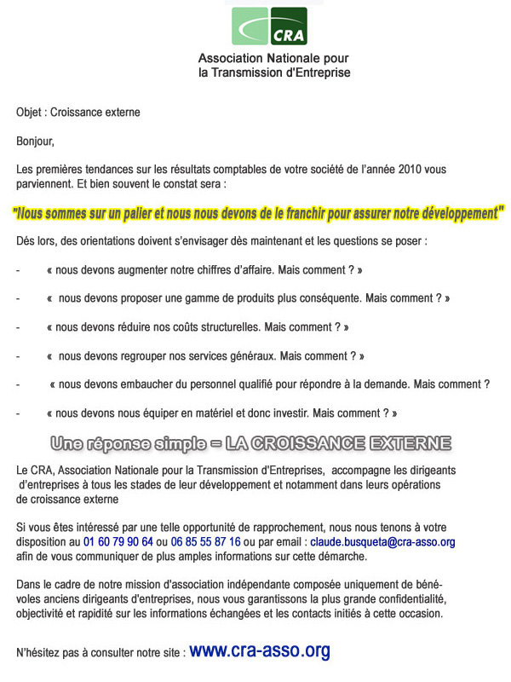](http://emailing.cra-asso.net/Mod_Mailings/MM_Tracking.asp?Envoi=20110103_133606&TB=C&ID=44705&NextURL=http://www.cra-asso.org)