TEASER CAPSTONE

A real estate investment company partnering SMEs, dedicated to accompanying its client-partners over the long term. Innovative positioning in a non-structured sector. Activity is 75% sale and leaseback of existing buildings, the remaining 25% comprising development of bespoke real estate solutions and services.

I - Proposal to Equity Investors

- Participate in the launch of the “SME Real Estate Investment Company” whose object is to provide small and medium sized enterprises with all services related to their real estate requirements: sale and leaseback, bespoke solutions, redevelopment, outsourced management… (unique positioning)
Create an original fund structure which will be floated on the Paris stock exchange within 5 years (exit for initial investors) with the following parameters :

  - Constitution of a high-yield real estate portfolio,
  - Risk/return profile : 10/10
  - Investment horizon (fund assets) : 10 years.

II - Management

Project promoter : Stéphane LIPP

- 37 years old,
- CNAM Commercial Law, MBA Corporate Finance - Fordham University (NY, USA),
- Wide experience in all aspects of commercial real estate investment (Financière Norbert Dentressangle, DTZ Thouard, Wal*Mart, …)
- Entrepreneur and investor in commercial real estate.

Management team : 4 finance and real estate professionals (average age 45) has been assembled and is ready to execute the business plan.

III – TRADING PARAMETERS

● Activity :

- Asset management and associated services relating to « non-prime » real estate assets of SMEs, comprising sale & leaseback, site restructuring/development and portfolio acquisition.

…/… 1-2
● Management & projections :
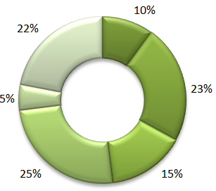
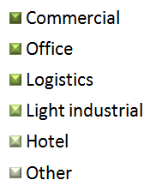
- Average gross rental yield 10.35 %
- Average lease length 10 years
- Leverage 50/50
- Average investment €5.8m
- Recurring revenues > 95%
- Investment markets France, Belgium
- Built area owned in Year 5 535 000 m²
- Diversification by asset type,
location and industry sector
- Protection of investors’interests
- Nombre de lignes 100 à 120,
- Protection des intérêts des actionnaires :
  - Management Team
  - Investment Committee
  - Board of Directors

IV – Keys projections
M€ | A1 | A2 | A3 | A4 | A5
Rental revenue | 5 | 17 | 31 | 44 | 59
EBITA | 2 | 13 | 26 | 39 | 53
Operating Cash flow | 0.1 | 8 | 18 | 27 | 39
Fixed assets | 125 | 227 | 340 | 446 | 550
Bank debt | 64 | 118 | 177 | 236 | 293

V - Financial Parameters

● Equity invesment : €267m issued in tranches as follows :

- Year 1 :

    - First tranche : €0.5m, Quarter1 2011
- Second tranche : €0.6m Quarter2 2011
- Third tranche : €22m - july 2011Acquisition of a light industrial park -50 tenants)
- Total year 1 : €67m

- Year 2 - Year 5 : €50m pa approx

● Exit : Year 5 Flotation

- Exit value €580m
- IRR : 25 %
- Investment by promoter : €15m
(development projects in progress at independent valuation)

VI – Project Status

- First 3 investments (of which one already in freehold ownership) under exclusive negotiation for a total of €70m.
2-2

