**BRY**

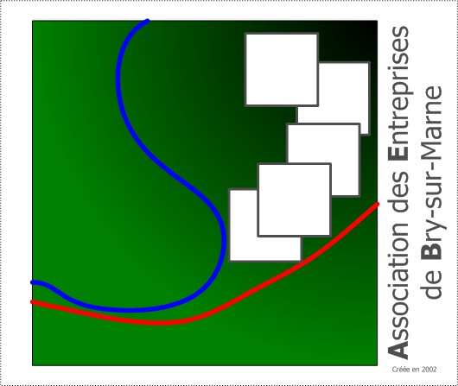

**Entreprises**

https://lh5.googleusercontent.com/Gwws52qbexvd5mTjh1txkEfStq9aqvw-C7jYixacCIqc_8GHRjNTQogARJY70ox9CikTqt_pMqKwrfb5liKfdrVStdyg_TEkqSKkOIBBp1VJSnFx2Q