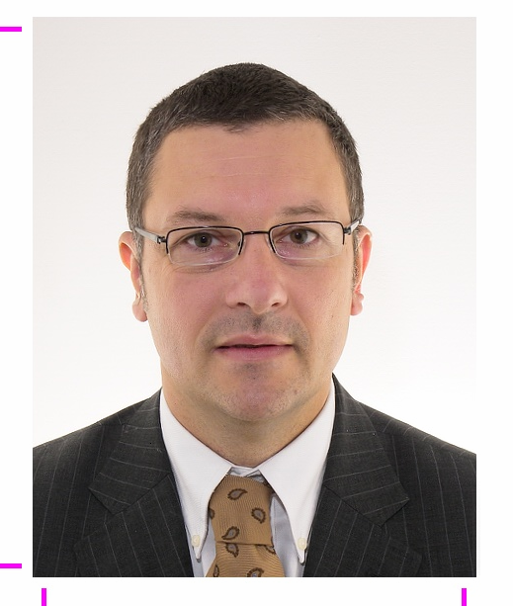
Nicolas RADZISZEWSKI
Birth date : 03/02/1970
Married, 4 kids
Contact adress:
La betelgeuse Bat B
413 Jacques Cartier street
83000 Toulon France
Phone number.: 0033494262346 Fax: 0033494264410
Mobile phone: 00420629754011 nsr@radwan.org

EDUCATION
1993-94 EM Lyon business school.
Postgratuated in Management of Technology and marketing.(Mastere)
1990-93 University of technology (UTC) Compiegne.
Engineer in Biotechnology
1988-90 High school in Mathematics and Biology in Lyon. Bellevue Lyceum.

PROFESSIONAL EXPERIENCE
2011 Senior Director of Central Europe, Sanofi Pasteur (19 EU countries)
2011 challenges: restructuration and reorganization of polish affiliate as General Director of Sanofi Pasteur Ltd, 56 employees, 20 Meuro TO

2006-2011 Director North and Central Europe
Achievement:sales growth by 50%
- Management and follow-up of medical, regulatory, marketing, commercial, financial, logistics, human resource activities of the region.
- Implementing the strategy for sustainable development.
- Restructuring of the subsidiaries with administrative integration to Sanofi aventis
- Participation in a repackaging operation transfer to the Central Europe.
- Responsible for the commercial launch of new products in 12 EU countries.
- Member of Executive Committee of Sanofi Aventis Ltd Czech Republic.
- Chairman of the vaccine manufacturers group in the Czech pharmaceutical association
- Member of European Vaccine Manufacturer Association.

2003-2006 Country Director: Sanofi Pasteur Gmbh in Czech Republic
Achievement: Sales growth by 300%
• Management of Sanofi Pasteur GmbH in Czech Republic
• Definition and implementation of business strategy, marketing, medical and regulatory, financial and administrative
• Responsible for negotiation with the distributors Gehe, Alliance, Phoenix
• Responsible for the lobbying activity in front of the Ministry of Health

1998- November 2003 Marketing Director expatriate, Rhone Poulenc company
• Elaboration and implementation of strategic planning
• Responsible for marketing dept. and sales budget
• Set up a marketing collaboration with a third company (Henkel)
• Organization of media campaigns and charitable vaccination campaigns at the national level

1996-98 International Product Manager expatriate, Rhone Poulenc company
• Coordination of marketing departments, medical, commercial and regulatory dpt.
• Elaboration of marketing plans
• Set up promotional campaigns for the launch of new products
• Establishment of clinical trials and pharmaco-economic survey
• Track Record of the regulatory activities

1995-1996 Assistant Country Manager, Rhone Poulenc company
• Market research, competitive intelligence, implementation of marketing and sales tools
• Medical Representative

1994 Pasteur Mérieux - Merck Sharp Dohme company (Lyon)
Marketing Europe, Product manager assistant
• Establishment of marketing tools and communication tools for the commercial launch of a new vaccine on the french market and European
• Marketing survey of a new product, conducting a marketing platform to subsidiaries.
1993 Commissariat à l'Energie Atomique (Saclay) et CNRS (Gif sur Yvette) - 7 months.
Research assistant-engineer thesis
• Culture of bacteria in industrial fermentors. Development of production of an enzyme and its subunits by different techniques of purification, and biochemical analysis.
• Publication in the journal Biochemical and Biophysical Acta 1995 review.
1992 Sanofi Elf Bio-Industry (Isle sur Sorgue) - 6 months.
Development of micro encapsulation in the food and pharmaceutical industries for the Middle East region. Setting up encapsulation systems in the laboratory phase, and then move to the industrial stage.

1989 Society Sagal (Spain), worker training - 1 month.
Production of salmons.

LANGUAGES
French: Mother tongue
Polish: Father tongue
English: reading, spoken and written. (Operational)
Spanish: passive (1 st language in college and graduate school, I didnt practiced for 15 years)
Czech: reading, spoken fluent, writing intermediate level
IT
IMS, program management of the sales force (Pharmsys)

INTERESTS
Nature, swimming,tennis, arts.
President of a non-profitable cooperative (1999-2001)

